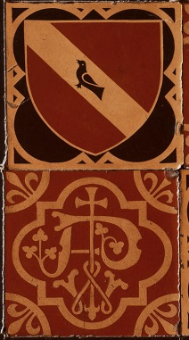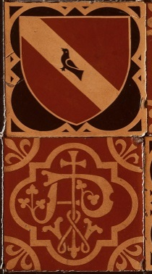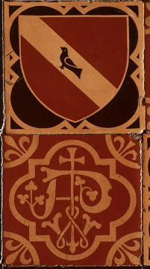 | Registration Form  Thank you for your interest in attending the colloquium on The Origins of Domestic Gothic Architecture in Ottawa Sept. 26-27, 2014. We have different numbers of seats for different components of the colloquium. Please let us know which events you will be able to attend (that way we won't book you a seat that could be used by others). There should be plenty of seats for the lectures, but they are limited for some of the tours. Deadline for TOUR registrations is Sept. 17, but we strongly urge earlier registration. We are holding some seats for Carleton University students and faculty as Carleton is paying the bulk of the costs, and they are learning of the event late; if some of those seats remain unfilled we will open additional spaces to the others on Sept. 18.  Name(s):  Please insert a letter "Y" before the lines below to indicate which events you wish to attend, save it as a Word file or insert the text in an email, and return it to Bruce Elliott by email. If your availability should change please let him know.  FRIDAY SEPT. 26  9:00 am bus tour to Pinhey's Point, Gothic churches, picnic lunch  1:30 pm bus tour to Earnscliffe (bus will leave people in Lower Town for dinner, or return them to Carleton as desired)  7:00 pm keynote lecture at St Alban's Church, 484 King Edward Ave. cor. Daly (NOTE: bus will leave Carleton 6:30)  I will take 6:30 Carleton bus to St Alban's  I will find my own way to St Alban's  I will take bus back to Carleton following lecture at St Alban's  SATURDAY SEPT 27 (NOTE: registration and exhibit viewing 8:00am)  9:00 am Lectures 2200 River Building Carleton  12:00-5:30 Bus tour to surviving pinwheel houses and lunch at Cabotto's restaurant  Cabotto’s menu will be set meal of salad, stuffed chicken, penne pasta with marinara sauce, and coffee/tea/soft drink  We require your full name to submit to Earnscliffe for that tour, for security reasons. My full name is:  I am:  Carleton University student or employee. If student state degree and program:  Heritage Ottawa member  Pinhey's Point Foundation member  Other  All buses depart Carleton University River Building at times indicated.  We will confirm your places no later than Sept. 18.  Colloquium fees:  Entire program is free to Carleton University students and employees. Lectures are free to all. There is a flat fee of $30 + 13% HST for others inclusive of lunches = $33.90. Details on how to pay will be provided following our receipt of this form.  Bruce Elliott  Bruce.Elliott@carleton.ca 613 798-2211

